# RASPBERRY PI 1

## INTRODUCTION

The Raspberry Pi 1, launched in 2012 by the Raspberry Pi Foundation, was a seminal device in the single-board computer (SBC) revolution. This series includes the original Model A and Model B, followed by improved Model A+ and Model B+ variants. While all share the same core Broadcom BCM2835 SoC, differences in RAM, connectivity, form factor, and power consumption distinguish them. Primarily conceived as an affordable educational tool to promote computer science learning in schools, its low cost, open nature, and versatile General Purpose Input /Output (GPIO) pins quickly saw its adoption by hobbyists, makers, and researchers for a wide array of projects. While often colloquially referred to as a "microcontroller" due to its embedded project usage, the Raspberry Pi 1 is a fully-fledged computer capable of running a Linux operating system, offering significantly more processing power and software flexibility than traditional microcontrollers like Arduinos.

This review will detail the specific design specifications and capabilities of each Raspberry Pi 1 model, analyse their respective advantages and disadvantages, and critically assess their suitability for various satellite subsystems, a domain where Commercial-Off-The-Shelf (COTS) components are increasingly considered for cost reduction in non-critical or research-oriented missions.

## DIAGRAMS AND SCHEMATICS

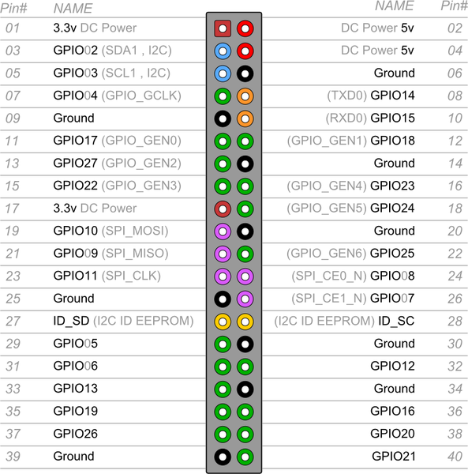

Figure 1: Raspberry Pi 1 pin out (Model A+ and B+ 40 pin header)

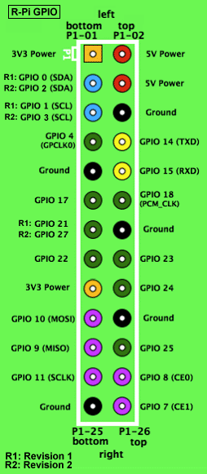

Figure 2: Raspberry pi 1 (Model A/B 26 pin header)

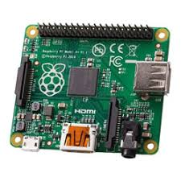

Figure 3: Raspberry Pi 1 board layout (Model A+)

## SPECIFICATIONS, CAPABILITIES, AND CHARACTERISTICS OF RASPBERRY PI 1 MODELS

### Core Common Architecture (All Raspberry Pi 1 Models)

* **System on Chip (SoC):** Broadcom BCM2835. This integrates:
  + **CPU:** A single-core ARM1176JZF-S processor typically clocked at 700MHz. This ARMv6 architecture was pivotal for running full Linux distributions.
  + **GPU:** A Broadcom Video Core IV GPU, capable of Blu-ray quality H.264 playback at 1080p30 and supporting OpenGL ES 2.0.
* **Operating System Support:** Primarily designed to run Linux distributions, with "Raspbian" (a Debian derivative optimized for Raspberry Pi hardware) being the officially supported OS. Other options include Arch Linux ARM, RISC OS.
* **Video Output:** HDMI output is standard. Composite video output is also available (via RCA on earlier models, TRRS jack on later ones).
* **Audio Output:** Analog audio via a 3.5mm jack and digital audio via HDMI.
* **Power Input:** 5V DC via Micro USB connector.
* **Fundamental Capabilities (derived from common core):**
  + Ability to run a desktop-like graphical environment (though performance-limited).
  + Execution of applications written in high-level languages (Python, C/C++, Perl, Java etc.).
  + Basic networking (model-dependent or via USB dongles).
  + Interfacing with external electronics through GPIO pins.

### Model-Specific Specifications and Characteristics

#### 3.2.1. Raspberry Pi Model A

* **RAM:** 256MB SDRAM (shared between CPU and GPU).
* **USB Ports:** 1x USB 2.0 port.
* **Ethernet:** None.
* **GPIO:** 26-pin header (P1).
* **Storage:** Full-size SD card slot.
* **Power Consumption:** Lowest of the initial models, typically around 1-1.5W under load.
* **Dimensions:** 85.60 mm × 56.5 mm.
* **Characteristics:** Designed as the lowest-cost variant. Its minimal peripheral set targeted applications where power and cost were paramount over connectivity. The single USB port and lack of Ethernet severely limited its out-of-the-box connectivity.

#### 3.2.2. Raspberry Pi Model B (Original and Revision 2.0)

* **RAM:**
  + Original Model B: 256MB SDRAM (shared).
  + Model B Revision 2.0 (released October 2012): Upgraded to 512MB SDRAM (shared). This upgrade significantly enhanced usability.
* **USB Ports:** 2x USB 2.0 ports.
* **Ethernet:** 10/100 Mbps Ethernet port. Notably, the Ethernet controller (Microchip LAN9512) was connected via the internal USB bus, meaning USB and Ethernet traffic shared bandwidth, a known performance bottleneck.
* **GPIO:** 26-pin header (P1). Revision 2.0 boards added an unpopulated 8-pin P5 header providing access to four more GPIO lines.
* **Storage:** Full-size SD card slot.
* **Power Consumption:** Higher than Model A, typically around 2.5-3.5W under load.
* **Dimensions:** 85.60 mm × 56.5 mm.
* **Characteristics:** The "standard" initial model, offering more connectivity (Ethernet, dual USB) and, with Rev 2.0, more usable RAM. This made it more suitable for general-purpose tinkering and projects requiring network access.

#### 3.2.3. Raspberry Pi Model A+

* **RAM:** 256MB SDRAM (shared). Some sources suggest BCM2835 batches used could support 512MB, but 256MB was the advertised standard.
* **USB Ports:** 1x USB 2.0 port.
* **Ethernet:** None.
* **GPIO:** Expanded to a 40-pin header, with the first 26 pins maintaining compatibility with Model A/B.
* **Storage:** Switched to a MicroSD card slot.
* **Power Consumption:** Lowest of all Pi 1 models, typically around 0.7-1.2W, due to more efficient power circuitry.
* **Dimensions:** Smaller form factor: 65 mm × 56.5 mm.
* **Characteristics:** An evolution of Model A, focusing on reduced size, lower power consumption, and an expanded GPIO header. It also featured improved audio circuitry. The move to MicroSD was in line with market trends.

#### 3.2.4. Raspberry Pi Model B+

* **RAM:** 512MB SDRAM (shared).
* **USB Ports:** Increased to 4x USB 2.0 ports. Power delivery to USB ports was also improved.
* **Ethernet:** 10/100 Mbps Ethernet port (still using a USB-connected controller, Microchip LAN9514, an evolution of the LAN9512).
* **GPIO:** Expanded to a 40-pin header, with the first 26 pins maintaining compatibility.
* **Storage:** Switched to a MicroSD card slot.
* **Power Consumption:** More efficient than the original Model B, typically around 2-3W under load, despite more USB ports.
* **Dimensions:** Similar footprint to Model B (85 mm × 56.5 mm), but with a neater port layout and four mounting holes.
* **Characteristics:** A significant refinement of the Model B. It offered much-improved I/O with four USB ports, the expanded GPIO, better power management, and a more practical layout. This became the de standard Pi 1 for more complex projects prior to the Pi 2.

## 4. ADVANTAGES AND DISADVANTAGES

**4.1. General Advantages (Applicable to all Raspberry Pi 1 Models)**

* **Full Linux Operating System:** Provided a familiar, powerful, and highly extensible software environment with access to vast repositories of open-source tools and libraries.
* **Versatile GPIO Interface:** Enabled direct interaction with external hardware, sensors, and actuators, bridging software with the physical world. The 40-pin header on A+/B+ was a notable improvement.
* **Strong Community Support:** A massive global community rapidly emerged, producing extensive documentation, tutorials, software, and troubleshooting support.
* **Multimedia Capabilities:** The VideoCore IV GPU offered respectable multimedia decoding for its class.

**4.2. General Disadvantages (Critical for Satellite Applications)**

* **Lack of Radiation Hardening:** As COTS consumer electronics, they possess no inherent protection against space radiation (Single Event Upsets - SEUs, Single Event Latch-ups - SELs, Total Ionizing Dose - TID effects), making them highly prone to malfunction or permanent damage in orbit.
* **SD Card Reliability:** The reliance on SD/MicroSD cards for boot and primary storage is a major point of failure. These cards are not designed for the write endurance, temperature extremes, or radiation environment of space, and are prone to data corruption.
* **Non-Real-Time Operating System:** Standard Linux distributions are not Real-Time Operating Systems (RTOS). This makes achieving deterministic timing for critical control loops (e.g., in ADCS or EPS) extremely challenging without specialized kernels (e.g., PREEMPT_RT patch), which add complexity and may not be fully validated for the BCM2835 (Jones, 2014).
* **Limited Processing Performance:** The single-core 700MHz ARM1176JZF-S CPU struggled with computationally intensive tasks, heavy multitasking, or modern complex software.
* **Thermal Management in Vacuum:** Consumer electronics rely on convective cooling. In vacuum, heat dissipation becomes a significant engineering challenge requiring dedicated conductive thermal pathways not present on the bare boards.
* **Commercial-Grade Components & Environmental Tolerance:** Connectors, solder joints, and components are not specified or tested for the vibration, shock, outgassing, and extreme temperature cycles of launch and space operation.
* **Power Consumption (Relative to Space-Grade Microcontrollers):** While low for a computer, their power draw (0.7W to 3.5W) is considerably higher than dedicated, low-power space-grade microcontrollers.

**4.3. Model-Specific Advantages/Disadvantages**

* **Model A/A+:**
  + ***Advantage:*** Lower power consumption is appealing for severely power-constrained scenarios. Model A+ had the smallest form factor.
  + ***Disadvantage:*** Limited RAM (256MB) is highly restrictive. Single USB port and no Ethernet severely limit connectivity without add-ons.
* **Model B/B+:**
  + ***Advantage:*** More RAM (512MB on Rev2.0 B and B+) provides better performance. Integrated Ethernet and more USB ports (especially the 4 on B+) offer superior connectivity. Model B+ had improved power circuitry and layout.
  + ***Disadvantage:*** Higher power consumption than A/A+. Shared USB/Ethernet bus on B/B+ can be a bottleneck.

## 5. SUITABILITY IN SATELLITE SUBSYSTEMS

The assessment of suitability is based on the general advantages and disadvantages of the Raspberry pi 1 series. Similarly, the different subsystems are considered.

**5.1. Telemetry, Tracking, and Command (TT&C)**

* **Role:** Handles vital two-way communication with ground control, processing commands, and transmitting satellite health and payload data.
* **Raspberry Pi 1 Model Suitability:**
  + While any model could technically interface with a radio transceiver via GPIO (UART, SPI), the risk of SD card corruption leading to loss of command reception or telemetry transmission is mission-ending.
  + The non-RTOS nature could lead to missed or mistimed commands.
  + Radiation-induced errors in the CPU or RAM during critical TT&C operations are catastrophic. No specific model offers a meaningful advantage given these fundamental flaws.

**5.2. On-Board Computer (OBC) / Command and Data Handling (C&DH)**

* **Role:** The central "brain" of the satellite, managing operations, scheduling tasks, processing payload data, storing data, and coordinating other subsystems.
* **Raspberry Pi 1 Model Suitability:**
  + The OBC is arguably the most critical subsystem. All the general disadvantages (radiation, SD card reliance, lack of RTOS, thermal) apply with extreme prejudice.
  + The 512MB RAM of the Model B (Rev 2.0) and Model B+ offers slightly more headroom for software than the 256MB models (A, A+), but this is insignificant compared to the overwhelming reliability risks.
  + For highly experimental, non-critical secondary data logging on a CubeSat with accepted high failure risk, a Model A+ (for low power) or B+ (for more connectivity to sensors) *might* be considered.

**5.3. Electrical Power System (EPS) Control**

* **Role:** Manages power generation (solar panels), storage (batteries), and distribution; monitors voltages, currents, and temperatures; controls charging and switching.
* **Raspberry Pi 1 Model Suitability:**
  + EPS is life-critical for the satellite. An RPi1's unreliability makes it an unacceptable choice for managing power distribution or battery charging. The non-RTOS nature is problematic for precise charging algorithms or load shedding responses.
  + Model A+ offers the lowest power draw, which is a minor consideration against the backdrop of unreliability.

**5.4. Communication (Payload Data Downlink / Inter-Satellite Links)**

* **Role:** Transmitting payload science data (often high volume) or establishing links with other satellites.
* **Raspberry Pi 1 Model Suitability:**
  + The CPU performance of all RPi1 models is insufficient for complex Software Defined Radio (SDR) tasks, error correction coding, or high-bandwidth modulation/demodulation.
  + For very low-data-rate, non-critical tasks like basic beaconing with a simple transceiver module (e.g., LoRa, via UART/SPI), any model *could* technically drive the module. Models B/B+ with Ethernet could simplify ground testing and integration with IP-based radio front-ends.

**5.5. Ground Stations**

* **Role:** Facilitates communication with the satellite from Earth, including antenna tracking, signal reception/demodulation, command uplink, and data display/archival.
* **RPi 1 Model Suitability:**
  + Here, the harsh space environment is absent. The low cost and Linux environment are advantageous.
  + **Model B+:** Its 512MB RAM, 4 USB ports (for keyboard, mouse, SDR dongle, other peripherals), and Ethernet make it the most suitable Pi 1 for amateur or educational ground station controllers, telemetry decoders, or simple data servers.
  + **Model B (Rev 2.0):** A viable, but less convenient, alternative due to fewer USB ports.
  + **Model A/A+:** Severely limited by single USB port and no Ethernet, making them impractical for most ground station setups without significant additional hub hardware.
  + Even here, performance for demanding SDR processing or handling multiple high-data-rate streams would be a limitation.

**5.6. Attitude Determination and Control System (ADCS)**

* **Role:** Determines and controls the satellite's orientation using sensors (sun sensors, magnetometers, gyros, star trackers) and actuators (reaction wheels, magnetorquers). Requires precise, real-time calculations and control loops.
* **Raspberry Pi 1 Model Suitability:**
  + ADCS is a highly critical, real-time control system. The non-RTOS nature of Linux on the RPi1, its limited processing power for complex navigation and control algorithms (e.g., Kalman filtering), and its inherent unreliability make it entirely inappropriate. Failure of the ADCS can lead to loss of communication, power generation, or mission objectives. The 40-pin GPIO on A+/B+ offers more sensor connectivity points, but the core system is inadequate for the task.

**6. Conclusion**

The Raspberry Pi 1 family (Models A, B, A+, B+) was a landmark achievement in terrestrial low-cost computing, fostering a generation of makers and learners. However, when evaluated against the stringent requirements of satellite subsystems, the models exhibit fundamental deficiencies that render them less suited for critical on-orbit applications. The lack of radiation hardening, reliance on unreliable SD card storage, the non-real-time nature of their typical operating system, limited processing power, and commercial-grade environmental tolerances are disqualifying factors for roles demanding high reliability and robust performance in the space environment.